WHAT I CAN DO

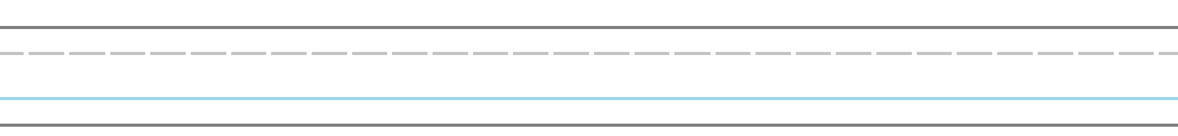
Hello!

I can

I like

I can’t

Thank you!

